ECEN 390 – Equation Sheet 2 (12/12/2024)
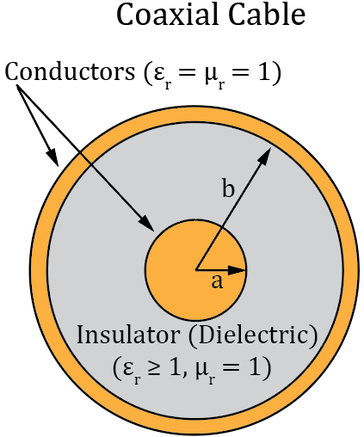
$$Coulombs Law: F_{e21}={\hat{R}}_{12}\frac{q_{1}q_{2}}{4πεR_{12}^{2}}. \text{Point Charge:}\text{ E }\text{=}\frac{q}{4πεR^{2}}\hat{R}. \left(At distance R from q\right).$$
$$\text{Conducting Sphere (Surface Charge = Q):}\text{ E }\text{=}\frac{Q}{4πεR^{2}}\hat{R}. \left(Outside at distance R from center\right).$$
$$\text{Infinite Line Charge (Line Charge Density = }{\text{ρ}}_{\text{l}}\text{): }\text{ E }\text{=}\frac{ρ_{l}}{2πεr}\hat{r}. \left(At distance r from line\right).$$
$$\text{Infinite sheet of charge (Surface Charge Density = }{\text{ρ}}_{\text{s}}\text{):}\text{ E }\text{=}\frac{ρ_{s}}{2ε}\hat{z}. \left(\hat{z} is a unit normal vector\right).$$
$$Permittivity: ε=ε_{r}ε_{0} with ε_{0} = 8.85 x {10}^{-12} F/m. \text{D} \text{=} ε\text{E}.$$
$Permeability: μ=μ_{r}μ_{0}, with μ_{0}=4π×{10}^{-7}H/m.$ $B=μH.$
$$Except for ferromagnetics, μ_{r}≈1 for dielectrics and conductors.$$
$$Coaxial Cable: C^{'}=\frac{2πε}{ln\left(b/a\right)}. L^{'}=\frac{μ}{2π}ln\left(\frac{b}{a}\right).$$
$$Parallel-Plate Capacitor: C= \frac{Q}{V}=\frac{ε_{r}ε_{0}A}{\text{d}}. W=\frac{1}{2}CV^{2}.$$
$$C_{eq_series}=\frac{1}{\frac{1}{C1}+\frac{1}{C2}+ ….. + \frac{1}{Cn}}. C_{eq_parallel}=C1+C2+…Cn.$$
$$\text{Inductance (Self-Inductance): }L=\frac{μ_{0}μ_{r}N^{2}S}{l}\text{ (H) for a solenoid., where N is the number of}$$
$$turns, S is cross sectional area, and l is solenoid length. Inductor Energy Storage W=\frac{1}{2}LI^{2}.$$
$$\text{Infinite straight wire carrying current I:}\text{ B }\text{=} μH=\hat{ϕ}\frac{μI}{2πr} \left(At radius r from the wire\right).$$
$$\text{Toroid with N turns and radius R carrying current I:}\text{ B }\text{=}-\hat{ϕ}\frac{μNI}{2πr} \left(Inside Toroid\right).$$
$$\text{Solenoid with N turns and length l carrying current I:}\text{ B }\text{=} \hat{z}\frac{μNI}{l} \left(Inside Solenoid\right).$$
$$Resistance: R=\frac{l}{σA} \left(Ω\right). Conductance: G=\frac{1}{R}=\frac{σA}{l} \left(S\right). Current Density: \text{J}\text{ = }\text{σ}\text{E}\text{ (A/}{\text{m}}^{\text{2}}\text{).}$$
$$Area of a circle A=πr^{2}, where r is the radius. Electrical Power p≜\frac{dw}{dt}. Energy: w=\int_{t_{0}}^{t}{p\left(t\right)dt.}$$
$$Wavelength: λ={u_{p}}/{f.} Phase velocity: u_{p}=λf =\frac{1}{\sqrt{με}}=\frac{c}{\sqrt{ε_{r}}}.$$
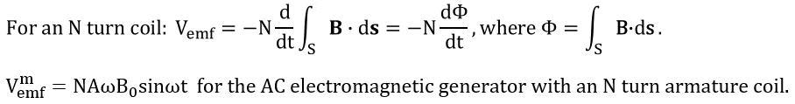
$$For an ideal transformer, P_{p}=P_{s}. \frac{V_{s}}{V_{p}}=\frac{N_{s}}{N_{p}}. \frac{I_{s}}{I_{p}}=\frac{N_{p}}{N_{s}}. Reflected impedance: Z_{in}=Z_{L}{\left[\frac{N_{p}}{N_{s}}\right]}^{2}.$$
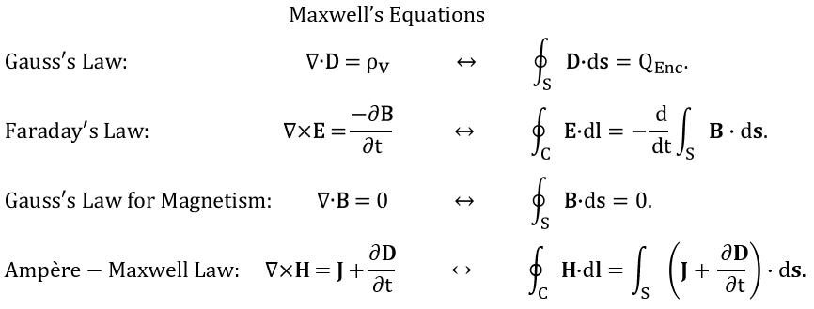
$$Intrinsic Impedance \left(eta\right): η=\sqrt{\frac{μ}{ε}}. \left|H\left(z,t\right)\right|=\frac{E_{x0}^{+}}{η}. Complex Permittivity: ε_{c}=ε-j\frac{σ}{ω}.$$
$$Skin depth: δ_{s}=1/{\sqrt{πfμσ}.}$$
$$For a round copper wire: R_{AC}=\frac{l}{\text{2}\text{π}\text{a}}\sqrt{\frac{πfμ}{σ}}, for radius a, lenght l, and f≫0.$$
$$Power Gain G_{dB}=10\log_{10}\left(\frac{P1}{P2}\right). Voltage Gain A_{dB}=20\log_{10}\left(\frac{V1}{V2}\right).$$
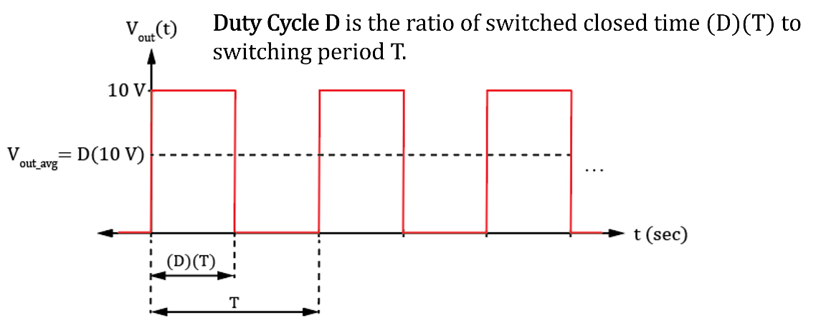
Solid Angle Ω = S/r² steradians (sr), where S is the spherical surface area subtended by a cone of radius r. The maximum solid angle is 4π sr, corresponding to a sphere.
Surface area of a sphere $A=4πr^{2}.$
Antenna Directivity D equals the ratio of the pattern solid angle of an isotropic antenna, i.e., 4π, to the pattern solid angle of the given antenna. 1 ≤ D ≤ ∞.
$$Radiation Efficiency: ξ≜\frac{P_{rad}}{P_{total}}.Antenna Gain G=ξD, resulting in G<D for real antennas.$$
For a Half-Wave Dipole Antenna, total antenna length is λ/2 with $R_{rad}≈73 Ω.$
For a Quarter-Wave Monopole Antenna, total antenna length is λ/4 with $R_{rad}≈37 Ω.$

